### Lab 07 Install and Configure Horizon

**Step 1 :** **Install Horizon**

# apt-get install openstack-dashboard

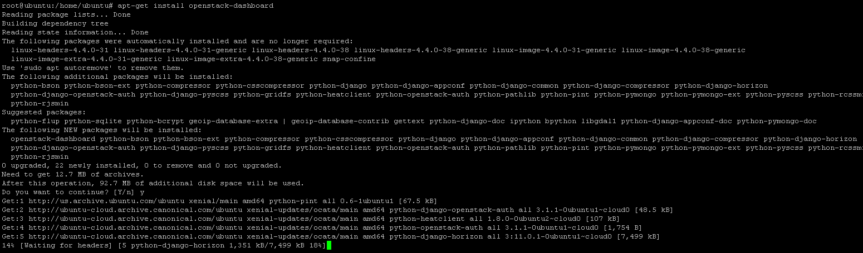

**Step 2 :** **Configure Horizon**

# vim /etc/openstack-dashboard/local_settings.py

OPENSTACK_HOST = "192.168.17.132"

OPENSTACK_KEYSTONE_URL = "http://%s:5000/v3" % OPENSTACK_HOST

OPENSTACK_KEYSTONE_DEFAULT_ROLE = "user"

ALLOWED _HOSTS = [‘*’]

OPESSTACK_KEYSTONE_MULTIDOMAIN_SUPPORT= TRUE

SESSION_ENGINE = 'django.contrib.sessions.backends.cache'

CACHES = {

'default': {

'BACKEND': 'django.core.cache.backends.memcached.MemcachedCache',

'LOCATION': '192.168.17.139:11211',

}

}

OPENSTACK_API_VERSIONS = {

"data-processing": 1.1,

"identity": 3,

“image”:2

"volume": 2,

# "compute": 2,

}

OPENSTACK_KEYSTONE_DEFAULT_DOMAIN = 'default'

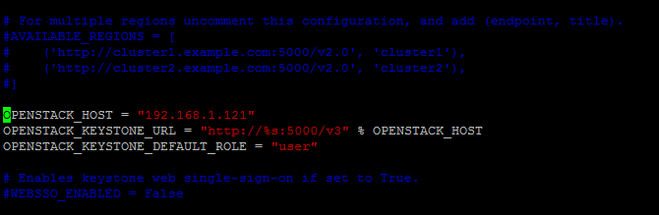

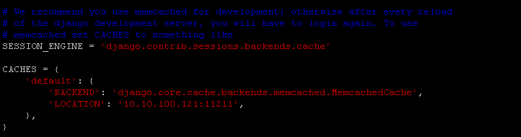

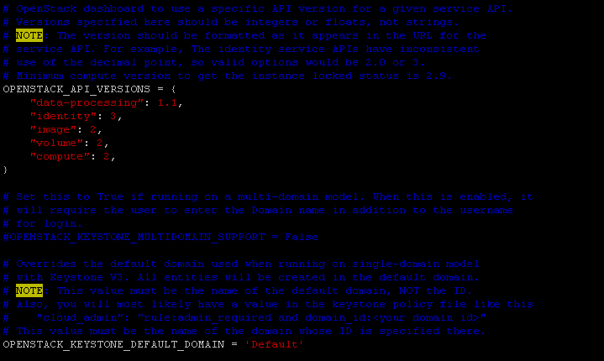

**Step 3 :** **Restart apache2 service**

# chown horizon /var/lib/openstack-dashboard/secret_key

service apache2 reload;



You can now access your OpenStack **192.168.0.70/horizon** with credentials **admin:admin_pass**